PPIT Mid 2

Finance and Accounting
- Need for Capital
New businesses, especially startups by computing graduates, require capital to begin operations.
Capital is needed for:
- Employee salaries
- Rent, utilities, and bills
- Equipment purchase
- Advertising and marketing costs
- Miscellaneous operational expenses
- Interest payments on borrowed funds
To obtain funding, a company must prepare a business plan that includes:
- A description of company activities and technical feasibility
- Founders’ expertise and experience
- Market size and competition assessment
- Predicted financial performance and profitability

- Sources of Funds
- Grants:
- Money given to a company for a specific purpose.
- Not required to be repaid.
- The recipient must prove that funds were used correctly.
- Loans:
- Borrowed money with interest (fixed or variable rate).
- Must be repaid within a specified period.
- If the company dissolves, lenders can recover funds by selling company assets.
- Equity Capital:
- Money invested in exchange for ownership (shares).
- Investors share in profits and losses.
- Advantage: No repayment obligation like loans.
- Disadvantage: Ownership and control are diluted.

- Budgeting and Monitoring
Budget –- financial plan estimating revenue and expenses over a specific period (usually a year).
It forecasts income, expenditure, and profit to guide financial decisions.
Budgeting is iterative — initial drafts often show excess spending, which is refined until a reasonable profit margin appears.

Monitoring involves comparing actual financial performance to budgeted figures (monthly or weekly).
- If actual spending exceeds the budget, reasons must be analyzed and corrective action taken promptly.

- Sales and Order Intake
Sale – exchange of goods or services for money.
Order Intake – measures the number of customer orders. It indicates production and future revenue.
Monitoring sales is essential since it affects:
- Pricing strategies
- Company costs and overheads
- Long-term financial planning

Costing
Pricing depends on:
- Production cost
- Market conditions
- Competitor prices
- Demand elasticity
Types of costs:
- Raw materials: Processed materials used in production.
- Brought-in items: Ready-made items integrated without change.
- Labour cost: Total wages and salaries.
- Equipment cost: Purchase price of tools and machinery.
- Overheads: Costs not tied to specific products (e.g., marketing, admin, rent).
- Departmental overheads: Linked to specific divisions.
- Corporate overheads: Apply to the whole organization.

Pricing
Pricing determines how much customers pay for products or services.
Prices must cover all costs and ensure profit.

Software companies deal with pricing in three main contexts:
- Service-based contracts (e.g., consultancy, design, programming).
- Bespoke software contracts — custom software made for one client at a fixed price.
- Off-the-shelf (OTS) software — pre-developed products sold to many customers.

Annual Statements
All companies must submit annual financial statements to authorities (e.g., Registrar of Companies).
Main components:
- Balance Sheet – shows assets and liabilities at a specific point in time.
- Profit and Loss Account – records income and expenditure over a period.

Balance Sheet:
- Financial snapshot showcasing what a company owns (assets) and owes (liabilities).
- Must balance — total assets = total liabilities + owners’ equity.
- Often includes previous year’s data for comparison.

Profit and Loss Account:
- Records all income and expenses during a financial year.
- In non-profit organizations, it is called an Income and Expenditure Account.

Capital and Its Maintenance
Capital – financial guarantee of a company’s stability.
Lenders evaluate company capital before approving loans.
To maintain capital:
- Shares cannot be issued at a discounted value.
- Original shareholder contributions cannot be repaid.

Auditing
Auditing – examining financial records to ensure accuracy and compliance with laws and standards.
Auditor’s Report – provides assurance that accounts offer a “true and fair view”.
Auditors:
- Examine internal financial procedures.
- Perform detailed checks on a sample of transactions.
Fraud detection is primarily the directors’ duty, but auditors must report any serious irregularities they find.

Cash Flow Statement
- Tracks the flow of cash — where it comes from and where it goes.
- Connects the balance sheet and the profit and loss account.
- Explains changes in cash position due to operating activities, investing activities and financing activities
- Helps determine liquidity and short-term financial health.

Overall Financial Picture
The balance sheet, profit and loss account, and cash flow statement are interdependent.
They must be analyzed together for an accurate assessment of financial status.
Example relationships:
- Profits (from P&L) increase assets (in Balance Sheet).
- Cash inflows/outflows (Cash Flow Statement) explain changes in cash assets.
Anatomy of a Software House

Introduction
Anatomy refers to the study of structure, organization, internal working, and hierarchy of an entity.
In the context of a software house, it involves understanding how different departments and roles are structured and how they interact to achieve organizational goals.
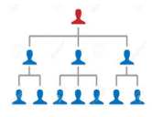

What Is a Software House?
Software House – company that primarily focuses on the development and distribution of software products.
Such companies may specialize in:
- Business software (e.g., ERP systems, accounting tools)
- Consumer software (e.g., mobile apps, games)
- Software-as-a-Service (SaaS) products (e.g., cloud-based tools)
The main objective is producing, selling, and maintaining software rather than hardware or general IT services.

Structure of a Typical Software House
Software Houses are structured in a hierarchical model, starting from ownership to specialized operational teams.
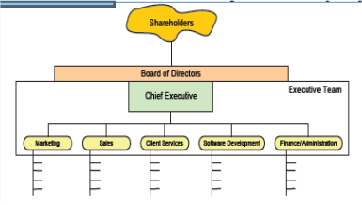
Below is the detailed anatomy:
- Shareholders
- Refers to the owners of the company who provide financial investment.
- Their key responsibilities include:
- Electing the Board of Directors.
- Voting on important company decisions.
- Ensuring corporate governance and ethical performance.
- This structure applies to both private and public limited companies.
- Board of Directors (BOD)
- Represents the interests of shareholders and governs organization strategically.
- Responsibilities:
- Define broad policies and strategic objectives.
- Select, appoint, and evaluate the Chief Executive Officer (CEO).
- Ensure availability of financial resources.
- Approve annual budgets and oversee financial accountability.
- Set compensation and benefits for senior management.
- Remain accountable to stakeholders for overall performance.
- Chief Executive Officer (CEO)
- Appointed by the Board of Directors.
- Responsibilities include:
- Communicating with shareholders, government entities, and the public.
- Leading the company’s short-term and long-term strategy.
- Defining and implementing the company’s vision and mission.
- Overseeing all departments and evaluating performance of executive leaders.
- Ensuring that the company achieves strategic growth and profitability.
- Executive Team
- Includes Vice Presidents (VPs) and C-level officers (e.g., CTO, CFO, COO, CMO).
- Managed by the CEO and responsible for day-to-day functional operations.
- Duties:
- Coordinate across departments to align strategy and budget.
- Develop operations in line with targets set by the Board and CEO.
- Make key decisions within their specific functional areas.
- Regularly conduct executive meetings to ensure consistent management.

Functional Departments in a Software House

Marketing Department
- Purpose: To create awareness and build the brand image of the company’s products.
- Responsibilities:
- Communicate effectively with target audiences and develop customer relationships.
- Design and execute marketing plans, advertising, and promotional campaigns.
- Conduct market research using surveys, focus groups, and customer feedback.
- Organize and attend events like conferences, exhibitions, and seminars.
- Support marketing managers in implementing agreed activities.
- Secure sponsorships and partnerships.

Sales Department
- Purpose: To convert leads into paying customers and drive revenue.
- Responsibilities:
- Conduct market research to identify customer needs and selling opportunities.
- Engage in cold calling, networking, and social media outreach.
- Set up meetings and prepare presentations for potential clients.
- Maintain sales reports and financial data for performance tracking.
- Negotiate deals, close sales, and handle customer complaints.
- Ensure product availability and delivery readiness.

Client Services Department
- Purpose: To manage ongoing customer relationships and ensure satisfaction.
- Responsibilities:
- Develop and maintain relationships with existing clients.
- Identify and engage potential clients for business growth.
- Prepare customized solutions to meet specific client needs.
- Negotiate terms to ensure profitable and efficient service delivery.
- Set appropriate pricing and manage expansion opportunities.
- Prepare annual business plans for assigned territories.

Software Development Department
- Purpose: To design, develop, and maintain software products or services.
- Responsibilities:
- Lead and mentor software engineers and developers.
- Provide project management and technical leadership.
- Define project lifecycles including research, design, development, testing, and delivery.
- Supervise architecture and maintain a technical roadmap for all projects.
- Establish software standards, processes, and best practices.
- Collaborate with product management to improve quality and scalability.

Finance and Administration Department
- Purpose: To manage company finances and oversee administrative operations.
- Responsibilities:
- Maintain financial management and internal controls.
- Ensure accurate and timely financial reporting.
- Handle budgeting, payroll, taxation, and accounting.
- Manage general administrative duties such as office maintenance and HR support.
- Provide essential financial data for decision-making and strategy planning.

Example: MindMill Software Ltd. (India)
- MindMill Software Ltd., established in 1993, is an example of a bespoke application development company (customized software solutions).
- It follows a structured hierarchy similar to the typical anatomy described, focusing on client-specific software solutions.
- The company emphasizes team-based project management, high-quality delivery standards, and close client collaboration.
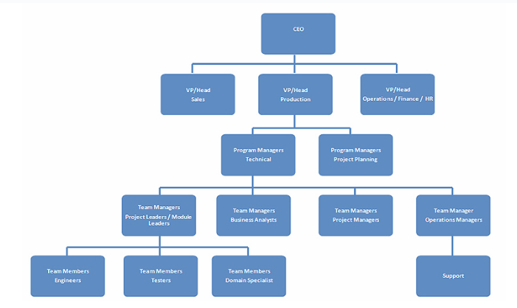

Computer/Software Contracts

Intellectual Property Rights

Present Value (PV) Problems

Investment Appraisal

Case Study

